**A PROJECT REPORTION**

**“WEB BASED ATTENDANCE MANAGEMENT SYSTEM”**

**FOR THE AWARD OF**

**DIPLOMA IN ELECTRONICS WITH SPECIALIZATION**

**IN**

**COMPUTER ENGINEERING**

**SUBMITTED BY**

**BARI. SRAVAN KUMAR**

**(PIN: 15054-CP-007)**

**MAY 2018 - NOVEMBER 2018**



**GOVT. INSTITUTE OF ELECTRONICS**

**EAST MARREDPALLY, SECUNDERABAD- 500026**



**STATE BOARD OF TECHNICAL EDUCATION & TRAININGHYDERABAD, TELANGANA.**



CERTIFICATE

This is to certify that the project entitled “**Student Attendance Management System for College**” submitted by Mr. **BARI. SRAVAN KUMAR,** bearing **PIN: 15054-CP-007**, student of final year **SPECIAL DIPLOMA** in COMPUTER PROGRAMMING ENGINEERING of **GOVERNMENT INSTITUTE OF ELECTRONICS**, East Marredpally, Secunderabad, has completed the project work during MAY 31ST2 2018 to NOVEMBER 30TH 2018, at CSE Section, **COMPUTER EDUCATION DIVISION** in ECIL.

**Signature of signature of**

**Project Guide Project In-charge**



**GOVERNMENT INSTITUTE OF ELECTRONICS  
 EAST MARREDPALLY, SECUNDERABAD-500026**

CERTIFICATE

This is to certify that the project entitled “**Student Attendance Management System For Colleges**” submitted by Mr. **BARI. SRAVAN KUMAR,** bearing **PIN:-15054-CP-007**, student of final year **SPECIAL DIPLOMA** in COMPUTER PROGRAMMING ENGINEERING of **GOVERNMENT INSTITUTE OF ELECTRONICS**, East Marredpally, Secunderabad. Has completed the project work during MAY 31ST to NOVEMBER 30TH 2018, at CSE section, **COMPUTER EDUCATION DIVISION** in ECIL.

**Sri. B. DAVID RAJU Sri. G. PULLAIAH**

Head of the Department, Principal,

Govt. Institute of Electronics, Govt. Institute of Electronics,

East Marredpally, East Marredpally,

Secunderabad. Secunderabad.

**ACKNOWLEDGEMENT**

I am very grateful to ELECTRONICS CORPORATION OF INDIA LIMITED giving this opportunity to fulfill my project report.

I would like to thank **Mr. Sridhar Shetty (In-charge, CED)** sir of the COMMUNICATION section who not only gave me opportunity to undergo industrial training in this organization but also encouraged me throughout endeavor.

I would like to express my sincere gratitude to our project guide

**Mr. V.Y. Bharadwaj sir, M.Tech**, who has gave me valuable information, precious advice to me in the department and implementation of this project.

I would like to express my profound gratitude to **Mr. G. PULLAIAH sir, Principal** and to **Mr. DAVID RAJU sir,** Head of the Computer Department, Govt. Institute of Electronics, Secunderabad for giving me an opportunity to work in Electronics Corporation of India Limited.

I also take an opportunity to thank the help extended by our colleagues and other people in making our project a successful travel.

**BY,**

**B. SRAVAN KUMAR,**

**PIN: 15054-CP-007,**

**ABOUT ECIL**

**OVERVIEW:**

ECIL was setup under the Department of Atomic Energy on 11th April, 1967 with a view to generate a strong indigenous capability in the field of professional grade electronics. The initial accent was on total self-reliance and ECIL was engaged in the Design, Development, Manufacture and Marketing of several products with emphasis on three technology lines viz. Computers, Control systems and Communications. Over the years, ECIL pioneered the developments of various complex electronics products without any external technologies help and scored several ‘firsts’ in these fields prominent among them being countries.

* OVEROOOOooohluliuuhuighgugggighhhhFirst Digital Computer.
* First solid State TV.
* First Control & Instrumentation of Nuclear Power Plants.
* First Earth Station Antenna.
* First Computerised Operator Information System.
* First Radiation Monitoring & Detection System.
* First Operating & Maintenance Cater for E-108 Exchange.
* First Programmable Logic controller.
* First Solid State Cockpit Voice Recorder.
* First Electronic Voting Machines.

**Objectives:-**

To continue services to the countries needs for the peaceful uses Atomic Energy. Special and Strategic Requirements of Defence and space, Electronics Security Systems and support for Civil Aviation sector.

* To establish new avenues of business and work for growth in strategic sector in addition to working for realizing technological solutions for the benefits of society in areas like Agriculture, Education, Health, Power, Transportation, Food, etc,.
* To establish newer technology products such as container scanning systems and Explosive Detectors.
* To progressively improve shareholder value of the company.
* To strength the technology base, enhance skill base and ensure succession planning in the company.
* To re-engineer the company to become nationally and internationally competitive by paying particular attention to delivery, cost and quality in all its activities.
* To consciously work for finding export makes for the company’s products.

In addition to its primary focus on chosen areas of strategic Electronics and IT, the company took upon itself certain areas with view to sub serve certain obligations of Enterprises. Mostly, they are confined to the societal and rural sectors focusing on health care, education, agriculture and such related areas.

ECIL manufactures and supplies a wide range of equipment which include:

* Control Room panels.
* Operator Information systems.
* Programmable controllers.
* Operator Training Simulators.
* Dual processor Hot Standby systems (DPHS).
* Reactor Regulating Systems.
* Electrical SCADA.
* Nuclear Instrumentation Modules like HV and Spectroscopy Amplifier, module Bins and Power supplies.
* Hand Held Survey and Contamination Monitors to detect Alpha, Beta and Gamma Radiation.
* Spectroscopy Systems using HP Germanium and Scintillation Detectors.
* Channels Analyser to perform an array of lab experiments.

SPECIFICATIONS:-

In a way all the strategic Business Units of ECIL are tuned to the varied requirements of Country’s Nuclear Power program, right from components to Complex systems. However, keeping in view, the ambitious programs of the Department of Atomic Energy, some divisions at totally dedicated to the nuclear sector.

They include:-

* Control and Automation Division (CAD).
* Radiation Detectors and Instrumentation Division (RID).
* Control & Instrumentation Division (CNID).

In addition to the above, the following Divisions offers select products and solutions in the areas of simulators, Supervisory Control, Security, Encryption etc.  
They are:

* Antenna Products & Satcom Division (AS&SD)
* Control & Instrumentation Division (ISG)
* Instruments and Systems Group (CNSG)
* Telecommunication Division (TCD)
* Communication Systems Group (CNSG)
* Customer Support Division (CSD)
* Components Division (CD)
* Computer Education Division(CED)

**DEFENCE VERTICAL:-**

ECIL has played a pioneering role in spurring the growth of Electronics Industry in the country. Spanning miniature components to mammoth systems and encompassing control, communication & computer technologies, today, ECIL is a multi-product. Multi-disciplinary

**ABSTRACT**

**TITLE OF PROJECT: WEB BASED ATTENDANCE MANAGEMENT SYSTEM FOR COLLEGES**

**INTRODUCTION:**

**The Attendance Management mainly concern with the access control data, easy to maintain the data, reports etc. The project deals with the attendance of the students in colleges.**

**The flow of the project:**

* **Maintains the semester wise attendance of student.**
* **Maintains the all semesters attendance of student in the college**
* **He can view his attendance in the website of any semester which he completed**

TABLE OF CONTENTS

|  |  |  |
| --- | --- | --- |
| Serial no. | Chapter name | Page no. |
| 1 | INTRODUCTION AND OVERVIEW | 10-11 |
| 2 | TECHNOLOGY ANALYSIS | 11-32 |
| 3 | Web Development | 32-40 |
| 4 | PROJECT ENHANCEMENT AND SUMMARY | 41 |
| 5 | OUTPUT | 42-62 |

1. Introduction and Project Overview
2. Technology Analysis
   1. CSS Creations
   2. HTML
   3. JDBC
   4. Java
   5. Java servlets page
   6. MySQL
3. Web Development
   1. Creation Of Website home Pages
   2. Connection
   3. Insert
   4. View
   5. Delete
   6. Update
   7. Login
   8. Modules
      1. Admin
      2. Staff
      3. Student
4. Project Enhancement and summary
5. Outputs

**1.0 INTRODUCTION AND PROJECT OVERVIEW**

**Introduction:** The Attendance Management mainly concern with the access control data, maintenance of attendance data, reports etc. This deals with attendance of a student in college.

**Purpose:**

It is designed to save time, avoid confusion in maintaining the data and avoiding loss of data

**SOFTWARE REQUIREMENTS:**

1. **CSS**
2. **HTML**
3. **NET BEANS**
4. **MY SQL**

**HARDWARE REQUIREMENTS:**

**HARDWARE:** Pentium based system with a minimum of p4 or above

**RAM: 1 GB**

**SCOPE:**

**Existing system:**

* At present time the attendance will be taking only in attendance registers
* The student cannot know how many leaves he took and how many days he present.
* If student not came to college he cannot know attendance

**Proposed system:**

* The whole attendance data will be saved in database and if any loss or data deleted we can restore it.
* Here in this system we will provide the no. of days absent, no. of days present, total working days and attendance percentage.
* The student can view his attendance from any place with the help of this website
* This website easy to understand to students, staff and student parents.
* And it is easy to staff or admin to run this website.
* Parents without coming to college they can monitor the attendance of their child.

2.O **TECHNOLOGY ANALYSIS**

Technology analysis describes the languages and technology (or) softwares we used in the developing of this website. In developing of this website we used 5 languages or technologies.

They are

1. CSS
2. HTML
3. JAVASCRIPT
4. JAVA
5. MYSQL

**2.1 CSS:**

**Cascading Style Sheets** (**CSS**) is a [style sheet language](https://en.wikipedia.org/wiki/Style_sheet_language) used for describing the [presentation](https://en.wikipedia.org/wiki/Presentation_semantics) of a document written in a [markup language](https://en.wikipedia.org/wiki/Markup_language) like [HTML](https://en.wikipedia.org/wiki/HTML). CSS is a cornerstone technology of the [World Wide Web](https://en.wikipedia.org/wiki/World_Wide_Web), alongside HTML and [JavaScript](https://en.wikipedia.org/wiki/JavaScript).

CSS is designed to enable the separation of presentation and content, including [layout](https://en.wikipedia.org/wiki/Page_layout), [colors](https://en.wikipedia.org/wiki/Color), and [fonts](https://en.wikipedia.org/wiki/Typeface). This separation can improve content [accessibility](https://en.wikipedia.org/wiki/Accessibility), provide more flexibility and control in the specification of presentation characteristics, enable multiple [web pages](https://en.wikipedia.org/wiki/Web_page) to share formatting by specifying the relevant CSS in a separate .css file, and reduce complexity and repetition in the structural content.

Separation of formatting and content also makes it feasible to present the same markup page in different styles for different rendering methods, such as on-screen, in print, by voice. CSS also has rules for alternate formatting if the content is accessed on a [mobile device](https://en.wikipedia.org/wiki/Mobile_device).

The name *cascading* comes from the specified priority scheme to determine which style rule applies if more than one rule matches a particular element. This cascading priority scheme is predictable.

2.2 HTML:

**Hypertext Markup Language** (**HTML**) is the standard [markup language](https://en.wikipedia.org/wiki/Markup_language) for creating [web pages](https://en.wikipedia.org/wiki/Web_page) and [web applications](https://en.wikipedia.org/wiki/Web_application). With [Cascading Style Sheets](https://en.wikipedia.org/wiki/Cascading_Style_Sheets) (CSS) and [JavaScript](https://en.wikipedia.org/wiki/JavaScript), it forms a triad of [cornerstone](https://en.wikipedia.org/wiki/Cornerstone) technologies for the [World Wide Web](https://en.wikipedia.org/wiki/World_Wide_Web).

[Web browsers](https://en.wikipedia.org/wiki/Web_browser) receive HTML documents from a [web server](https://en.wikipedia.org/wiki/Web_server) or from local storage and [render](https://en.wikipedia.org/wiki/Browser_engine) the documents into multimedia web pages. HTML describes the structure of a web page [semantically](https://en.wikipedia.org/wiki/Semantic_Web) and originally included cues for the appearance of the document.

[HTML elements](https://en.wikipedia.org/wiki/HTML_element) are the building blocks of HTML pages. With HTML constructs, [images](https://en.wikipedia.org/wiki/HTML_element#Images_and_objects) and other objects such as [interactive forms](https://en.wikipedia.org/wiki/Fieldset) may be embedded into the rendered page. HTML provides a means to create [structured documents](https://en.wikipedia.org/wiki/Structured_document) by denoting structural [semantics](https://en.wikipedia.org/wiki/Semantics) for text such as headings, paragraphs, lists, [links](https://en.wikipedia.org/wiki/Hyperlink), quotes and other items. HTML elements are delineated by *tags*, written using [angle brackets](https://en.wikipedia.org/wiki/Bracket#Angle_brackets). Tags such as <img/> and <input/> directly introduce content into the page. Other tags such as <**p**> surround and provide information about document text and may include other tags as sub-elements. Browsers do not display the HTML tags, but use them to interpret the content of the page.

HTML can embed programs written in a [scripting language](https://en.wikipedia.org/wiki/Scripting_language) such as [JavaScript](https://en.wikipedia.org/wiki/JavaScript), which affects the behavior and content of web pages. Inclusion of CSS defines the look and layout of content.

**HTML TAGS:**

Basic HTML Tags:

<!-- --> Specifies comments

<A>……….</A> Creates hypertext links

<B>……….</B> Formats text as bold

<BIG>……….</BIG> Formats text in large font.

<BODY>…</BODY> Contains all tags and text in the HTML document

<CENTER>...</CENTER> Creates text

<DD>…</DD> Definition of a term

<DL>...</DL> Creates definition list

<FONT>…</FONT> Formats text with a particular font

<FORM>...</FORM> Encloses a fill-out form

<FRAME>...</FRAME> Defines a particular frame in a set of frames

<H#>…</H#> Creates headings of different levels

<HEAD>...</HEAD> Contains tags that specify information about a document

<HR>...</HR> Creates a horizontal rule

<HTML>…</HTML> Contains all other HTML tags

<META>...</META> Provides meta-information about a document

<SCRIPT>…</SCRIPT> Contains client-side or server-side script

<TABLE>…</TABLE> Creates a table

<TD>…</TD> Indicates table data in a table

<TR>…</TR> Designates a table row

<TH>…</TH> Creates a heading in a table

**Advantages:**

* + A HTML document is small and hence easy to send over the net. It is small because it does not include formatted information.
  + HTML is platform independent.

HTML tags are not case-sensitive.

**2.3 JDBC:**

JDBC is an API for the Java programming language that defines how a client may access a database. It provides methods for querying and updating data in a database. JDBC is oriented towards relational databases.

JDBC was first introduced in the Java 2 Platform, Standard Edition, version 1.1 (J2SE), together with a reference implementation JDBC-to-ODBC bridge, enabling connections to any ODBC-accessible data source in the JVM host environment.

## FUNCTIONALITY:

JDBC allows multiple implementations to exist and be used by the same application. The API provides a mechanism for dynamically loading the correct Java packages and registering them with the JDBC Driver Manager. The Driver Manager is used as a connection factory for creating JDBC connections.

JDBC connections support creating and executing statements. These may be update statements such as SQL's CREATE, INSERT, UPDATE and DELETE, or they may be query statements such as SELECT. Additionally, stored procedures may be invoked through a JDBC connection. JDBC represents statements using one of the following classes:

* Statement – the statement is sent to the database server each and every time.
* Prepared Statement – the statement is cached and then the execution path is pre-determined on the database server allowing it to be executed multiple times in an efficient manner.
* Callable Statement – used for executing stored procedures on the database.

Update statements such as INSERT, UPDATE and DELETE return an update count that indicates how many rows were affected in the database. These statements do not return any other information.

Query statements return a JDBC row result set. The row result set is used to walk over the result set. Individual columns in a row are retrieved either by name or by column number. There may be any number of rows in the result set. The row result set has metadata that describes the names of the columns and their types.

2.4 JAVA:

**JAVA:**

Java is a programming language originally developed by James Gosling at Sun Microsystems (which is now a subsidiary of Oracle Corporation) and released in 1995 as a core component of Sun Microsystems' Java platform. The language derives much of its syntax from C and C++ but has a simpler object model and fewer low-level facilities. Java applications are typically compiled to byte code (class file) that can run on any Java Virtual Machine (JVM) regardless of computer architecture. Java is general-purpose, concurrent, class-based, and object-oriented, and is specifically designed to have as few implementation dependencies as possible. It is intended to let application developers "write once, run anywhere". Java is considered by many as one of the most influential programming languages of the 20th century, and is widely used from application software to web applications.

The original and reference implementation Java compilers, virtual machines, and class libraries were developed by Sun from 1995. As of May 2007, in compliance with the specifications of the Java Community Process, Sun relicensed most of its Java technologies under the GNU General Public License. Others have also developed alternative implementations of these Sun technologies, such as the GNU Compiler for Java and GNU Classpath.

**PRINCIPLES:**

There were five primary goals in the creation of the Java language: It should be "simple, object oriented, and familiar".

* It should be "robust and secure".
* It should be "architecture neutral and portable".
* It should execute with "high performance".
* It should be "interpreted, threaded, and dynamic.

#### **Performance:**

Programs written in Java have a reputation for being slower and requiring more memory than those written in some other languages. However, Java programs' execution speed improved significantly with the introduction of Just-in-time compilation in 1997/1998 for Java 1.1, the addition of language features supporting better code analysis (such as inner classes, StringBuffer class, optional assertions, etc.), and optimizations in the Java Virtual Machine itself, such as Hotspots becoming the default for Sun's JVM in 2000.

## Syntax:

The syntax of Java is largely derived from C++. Unlike C++, which combines the syntax for structured, generic, and object-oriented programming, Java was built almost exclusively as an object oriented language. All code is written inside a class and everything is an object, with the exception of the intrinsic data types (ordinal and real numbers, boolean values, and characters), which are not classes for performance reasons.

Java suppresses several features (such as operator overloading and multiple inheritance) for *classes* in order to simplify the language and to prevent possible errors and anti-pattern design.

Java uses similar commenting methods to C++. There are three different styles of comment: a single line style marked with two slashes (//), a multiple line style opened with a slash asterisk (/*) and closed with an asterisk slash (*/) and the Javadoc commenting style opened with a slash and two asterisks (/**) and closed with an asterisk slash (*/). The Javadoc style of commenting allows the user to run the Javadoc executable to compile documentation for the program.

### FEATURES OF JAVA:

### PLATFORM INDEPENDENT:

### The concept of Write-once-run-anywhere (known as the Platform independent) is one of the important key feature of java language that makes java as the most powerful language. Not even a single language is idle to this feature but java is more closer to this feature. The programs written on one platform can run on any platform provided the platform must have the JVM.

**SIMPLE:**

There are various features that make the java as a simple language. Programs are easy to write and debug because java does not use the pointers explicitly. It is much harder to write the java programs that can crash the system but we cannot say about the other programming languages. Java provides the bug free system due to the strong memory management. It also has the automatic memory de-allocation.

**OBJECTORIENTED:**

To be an Object Oriented language, any language must follow at least the four characteristics.

* **Inheritance:**

It is the process of creating the new classes and using the behavior of the existing classes by extending them just to reuse  the existing code and adding the additional features as needed.

* **Encapsulation:**

It is the mechanism of combining the information and providing the abstraction.

* **Polymorphism:**

As the name suggest one name multiple form, Polymorphism is the way of providing the different functionality by the functions having the same name based on the signatures of the methods.

* **Dynamic binding:**

Sometimes we don't have the knowledge of objects about their specific types while writing our code. It is the way of providing the maximum functionality to a program about the specific type at runtime.  As the languages like Objective C, C++ fulfills the above four characteristics yet they are not fully object oriented languages because they are structured as well as object oriented languages. But in case of java,  it is a fully Object Oriented language because object is at the outer most level of data structure in java. No stand alone methods, constants, and variables are there in java. Everything in java is object even the primitive data types can also be converted into object by using the wrapper class.

* **Distributed**:

The widely used protocols like HTTP and FTP are developed in java. Internet programmers can call functions on these protocols and can get access the files from any remote machine on the internet rather than writing codes on their local system.

* **Portable:**

The feature Write-once-run-anywhere  makes the java language portable provided that the system must have interpreter for the JVM. Java also have the standard data size irrespective of [operating system](http://www.roseindia.net/java/java-introduction/java-features.shtml) or the processor. These features makes the java as a portable language.

* **Dynamic:**  
  While executing the [java program](http://www.roseindia.net/java/java-introduction/java-features.shtml) the user can get the required files dynamically from a local drive or from a computer thousands of miles away from the user just by connecting with the Internet.
* **Secure:**  
  Java does not use memory pointers explicitly. All the programs in java are run under an area known as the sand box. Security manager determines the accessibility options of a class like reading and writing a file to the local disk. Java uses the public key encryption [system](http://www.roseindia.net/java/java-introduction/java-features.shtml) to allow the java applications to transmit over the internet in the secure encrypted form. The bytecode Verifier checks the classes after loading.
* **Performance:** Java uses native code usage, and lightweight process called  threads. In the beginning interpretation of byte code resulted the performance slow but the advance version of JVM uses the adaptive and just in time compilation technique that improves the performance.
* **Multithreaded:**As we all know several features of Java like Secure, Robust, Portable, dynamic etc; you will be more delighted to know another feature of Java which is Multithreaded.  
   Java is also a Multithreaded programming language. Multithreading means a single program having different threads executing independently at the same time. Multiple threads execute instructions according to the program code in a process or a program. Multithreading works the similar way as multiple processes run on one [computer](http://www.roseindia.net/java/java-introduction/java-features.shtml). Multithreading programming is a very interesting concept in Java. In multithreaded programs not even a single thread disturbs the execution of other thread. Threads are obtained from the pool of available ready to run threads and they run on the system CPUs.
* **Interpreted:** We all know that Java is an interpreted language as well. With an interpreted language such as Java, programs run directly from the source code. The interpreter program reads the source code and translates it on the fly into computations. Thus, Java as an interpreted language depends on an interpreter program. The versatility of being platform independent makes Java to outshine from other languages. The source code to be written and distributed is platform independent.  Another advantage of Java as an interpreted language is its error debugging quality. Due to this any error occurring in the program gets traced. This is how it is different to work with Java.
* **Architecture Neutral:**

The term architectural neutral seems to be weird, but yes Java is an architectural neutral language as well. The growing popularity of networks makes developers think distributed. In the world of network it is essential that the applications must be able to migrate easily to different computer systems. Not only to [computer systems](http://www.roseindia.net/java/java-introduction/java-features.shtml) but to a wide variety of hardware architecture and operating system architectures as well.  The Java compiler does this by generating byte code instructions, to be easily interpreted on any machine and to be easily translated into native machine code on the fly.The compiler generates an architecture-neutral object file format to enable a Java [application](http://www.roseindia.net/java/java-introduction/java-features.shtml) to execute anywhere on the network and then the compiled code is executed on many processors, given the presence of the Java runtime system.Hence Java was designed to support applications on network. This feature of Java has thrived the programming language.

**2.5 JAVA SERVLET PAGES:**

Java server Pages is a simple but powerful technology used to generate dynamic web pages on the server side. JSP’s are direct extension of java servlets and provide a way to separate content generation from content presentation.

**FEATURES OF JSP:**

**Portability:**

Java Server Pages files can be run on any web server or web-enabled application server that provides support for them. Dubbed the JSP engine, this support involves recognition, translation, and management of the Java Server Page lifecycle and its interaction components.

**Components:**

It was mentioned earlier that the Java Server Pages architecture can include reusable Java components. The architecture also allows for the embedding of a scripting language directly into the Java Server Pages file. The components current supported include Java Beans, and Servlets.

**Processing:**

A Java Server Pages file is essentially an HTML document with JSP scripting or tags. The Java Server Pages file has a JSP extension to the server as a Java Server Pages file. Before the page is served, the Java Server Pages syntax is parsed and processed into a Servlet on the server side. The Servlet that is generated outputs real content in straight HTML for responding to the client.

2.6 MYSQL:

**MySQL** is an [open source](https://en.wikipedia.org/wiki/Open-source_software) [relational database management system](https://en.wikipedia.org/wiki/Relational_database_management_system) (RDBMS). "[SQL](https://en.wikipedia.org/wiki/SQL)", abbreviation is [Structured Query Language](https://en.wikipedia.org/wiki/Structured_Query_Language). MySQL software delivers a very fast, multithreaded, multi user and robust sql database server. MySQL server is intended for mission-critical, heavy-load production systems as well as for embedding into mass-deployed software. Oracle is a registered trademark of oracle corporation.

* MySQL is ideal for both small and large applications.
* MySQL is very fast, reliable and easy to use.
* MySQL compiles on a number of platforms.
* MySQL is free to download and use.

In MySQL , data is stored in tables. A table is a collection of related data and it consists of columns and rows.

Right-click the Databases node in the Services window and choose Register MySQL Server to open the MySQL Server Properties dialog box.

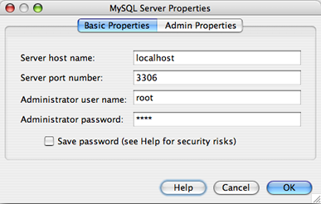

1. Confirm that the server host name and port are correct.

Notice that the IDE enters localhost as the default server host name and 3306 as the default server port number.

1. Enter the Administrator user name (if not displayed).
2. Enter the Administrator password. The default is set to blank.
3. Click the Admin Properties tab at the top of the dialog box.

The Admin Properties tab is then displayed, allowing you to enter information for controlling the MySQL Server.

1. In the Path/URL to admin tool field, type or browse to the location of your MySQL Administration application such as the MySQL Admin Tool, PhpMyAdmin, or other web-based administration tools.
2. In the Path to start command, type or browse to the location of the MySQL start command. To find the start command, look for MySQLd in the bin folder of the MySQL installation directory.
3. In the Path to stop command field, type or browse to the location of the MySQL stop command. This is usually the path to MySQL admin in the bin folder of the MySQL installation directory. If the command is mysqladmin, in the Arguments field, type -u root stop to grant root permissions for stopping the server.
4. When finished, the Admin Properties tab should resemble the following figure. If you are satisfied with your configuration, click OK.

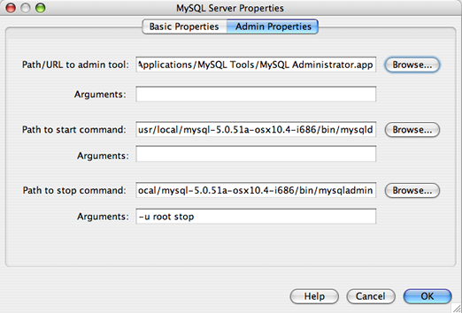

## Creating Database Tables

Now that you have connected to MyNewDatabase, you can begin exploring how to create tables, populate them with data, and modify data maintained in tables. This allows you to take a closer look at the functionality offered by the Database Explorer, as well as NetBeans IDE's support for SQL files.

MyNewDatabase is currently empty. In the IDE it is possible to add a database table by either using the Create Table dialog, or by inputting an SQL query and running it directly from the SQL Editor. In the following exercises you will use the SQL editor to create the Counselor table and the Create Table dialog box to create the Subject table. After you create the tables you will run an SQL script to populate the tables.

1. [Using the SQL Editor](https://netbeans.org/kb/docs/ide/mysql.html#usingSQLEditor)
2. [Using the Create Table Dialog](https://netbeans.org/kb/docs/ide/mysql.html#usingCreateTable)

### Using the SQL Editor

In this exercise you will use the SQL editor to create the Counselor table.

1. In the Database Explorer, expand the MyNewDatabase connection node (connection node icon) and note that there are three subfolders: Tables, Views and Procedures.
2. Right-click the Tables folder and choose Execute Command. A blank canvas opens in the SQL Editor in the main window.
3. In the SQL Editor, type in the following query. This is a table definition for the Counselor table you are about to create.
4. CREATE TABLE attendance (
5. StudentName VARCHAR (50),
6. FatherName VARCHAR (50),
7. DOB VARCHAR (50),
8. Mobile Number VARCHAR (25),
9. Email VARCHAR (50),
10. PRIMARY KEY (Pin Number)

);

1. To execute the query, either click the Run SQL (run SQL button) button in the task bar at the top (Ctrl-Shift-E), or right-click within the SQL Editor and choose Run Statement. The IDE generates the Counselor table in the database, and you receive a message similar to the following in the Output window.
2. To verify changes, right-click the Tables node in the Database Explorer and choose Refresh. The Refresh option updates the Database Explorer's UI component to the current status of the specified database. Note that the new Counselor table node () now displays under Tables in the Database explorer. If you expand the table node you can see the columns (fields) you created, starting with the primary key .

### Using the Create Table Dialog

In this exercise you will use the Create Table dialog box to create the Subject table.

1. In the Database Explorer, right-click the Tables node and choose Create Table. The Create Table dialog opens.
2. In the Table name text field, type Subject.
3. Click Add Column.
4. For the Name of the column, enter id. Choose SMALLINT for data type from the Type drop-down list. Click OK.
5. 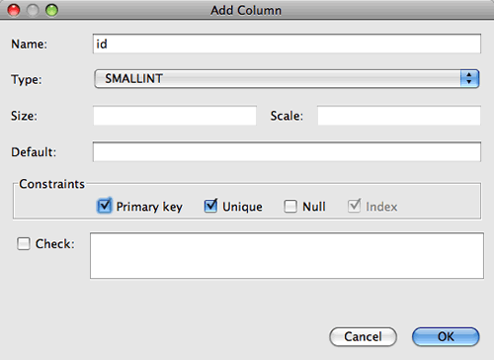
6. Select the Primary Key check box in the Add Column dialog box. You are specifying the primary key for your table. All tables found in relational databases must contain a primary key. Note that when you select the Key check box, the Index and Unique check boxes are also automatically selected and the Null check box is deselected. This is because primary keys are used to identify a unique row in the database, and by default form the table index. Because all rows need to be identified, primary keys cannot contain a Null value.

**SQL COMMANDS:**

SQL commands are mainly categorized into four categories:

* **DDL(Data definition Language):**

DDL actually consists of the SQL commands that are used to define the database schema.

It is used to create and modify the structure of database objects in database.

Example: CREATE

DROP.

[syntax: DROP TABLE table_name;].

RENAME

* **DML(Data Manipulation Language):**

The SQL commands that deal with the manipulation of data present in database belong to DML or Data Manipulation Language and this includes most of the SQL statements.

Example:

**SELECT**

[syntax: SELECT column1,column2,…FROM table_name]

**INSERT**

[syntax: INSERT INTO table_name(column-names)]

**UPDATE**

[syntax: UPDATE table_name SET column1=value1,column2=value2,…

WHERE condition;]

**DELETE.**

[syntax: DELETE FROM table_name WHERE condition;]

* **DCL(Data Manipulation Language):**

DCL includes commands like GRANT and REVOKE which mainly deals with the rights, permissions and other controls of the database system.

Example:

**GRANT,**

[Syntax: GRANT privilege-type ON [TABLE]{table-Name | view-name}TO grantees

**REVOKE.**

[Syntax: REVOKE privilege-type ON [TABLE]{table-Name | view-Name} FROM grantees

**TCL (Transaction Control Language):**

TCL deals with the transactions within the database. They are used to manage the changes made to the data in the table by DML statements.

It also allows statements to be grouped together into logical transactions.

Example: **COMMIT.**

**[**syntax: COMMIT;]

**ROLLBACK.**

Syntax :ROLLBACK TO savepoint_name;

**3.0 WEB DEVELOPMENT:**

**Web development** is the work involved in developing a web site for the Internet (World Wide Web) or an intranet (a private network). Web development can range from developing a simple single static pageof plain text to complex web-based internet applications (web apps) electronic businesses, and social network services. A more comprehensive list of tasks to which web development commonly refers, may include web engineering, web design, web content development, client liaison, client-side/server-side scripting, web server and network security configuration, and e-commerce development. Among web professionals, "web development" usually refers to the main non-design aspects of building web sites: writing markup and coding. Most recently Web development has come to mean the creation of content management systems (CMS). These CMS can be made from scratch, proprietary or open source. In broad terms the CMS acts as middleware between the database and the user through the browser. A principle benefit of a CMS is that it allows non-technical people to make changes to their web site without having technical knowledge.

For larger organizations and businesses, web development teams can consist of hundreds of people (web developers) and follow standard methods like Agile methodologies while developing websites. Smaller organizations may only require a single permanent or contracting developer, or secondary assignment to related job positions such as a graphic designer or information systems technician. Web development may be a collaborative effort between departments rather than the domain of a designated department. There are three kinds of web developer specialization: front-end developer, back-end developer, and full-stack developer. Front-end developers deal with the layout and visuals of a website, while back-end developers deal with the functionality of a website. Back-end developers will program in the functions of a website that will collect data.

**3.1 creation of website homepage using CSS**

In our website we used CSS3 menus for creation of website homepages. With the help of CSS3 it becomes easy to create a homepage of our own. CSS3 is a easily understandable application. It helps us in creating a webpage and in this we can add logo for each menu as it helps to recognize the menu.

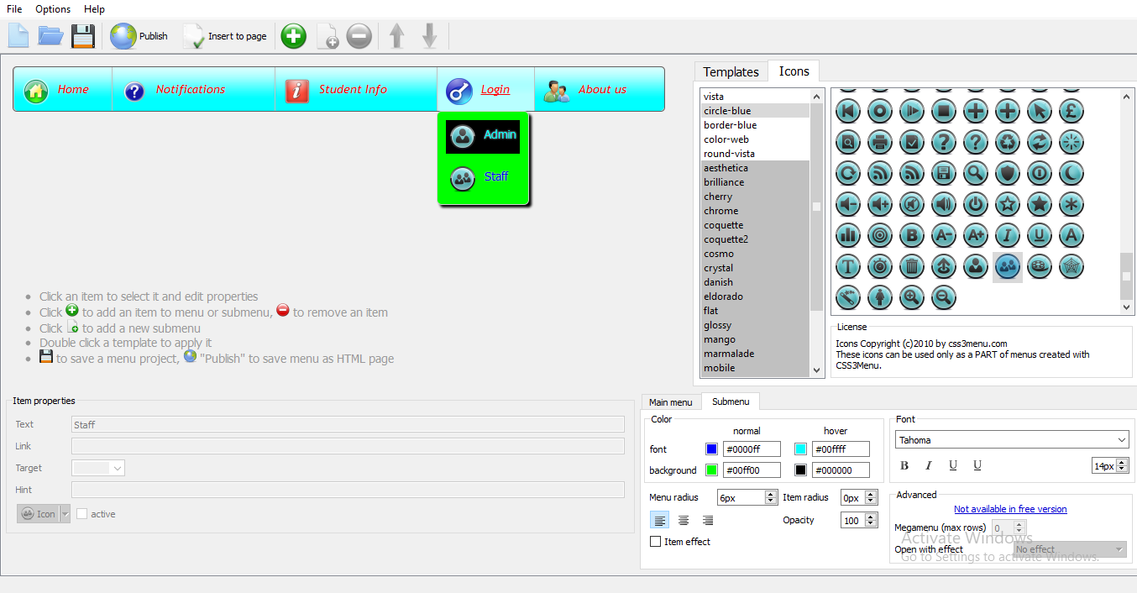

The above picture shows the creation of website homepages using CSS 3 menus.

3.2 **CONNECTION PAGE**

This demonstrates how to setup a connection to a MySQL database from the NetBeans IDE. Once connected, you can begin working with MySQL in the IDE’s database Explorer by creating new databases and tables, populating tables with data, and running SQL queries on database structures and content. This tutorial is designed for beginners with a basic understanding of database management, who want to apply their knowledge to working with MySQL in NetBeans IDE.

[MySQL](http://www.mysql.com/) is a popular Open Source relational database management system (RDBMS) commonly used in web applications due to its speed, flexibility and reliability. MySQL employs SQL, or *Structured Query Language*, for accessing and processing data contained in databases.

The data given will be stored in tables in database. This avoids the confusion and inter mixing of data

3.3 **INSERT**

Insert command is used to store the given data in database. With help of the insert code the user registration works. The insert is a SQL command. The data stored by insert will be used in login by getting the username , password etc.

3.4 **VIEW**

View command helps us to view the data stored in database. It will be used to show the inserted data in database as per column wise, row wise, or according to the given condition. It mainly used to view the profile, registered users etc.

3.5 DELETE

Delete command is used to delete unnecessary data or values in database. This will be used when any student completed his college, then his data will be deleted.

3.6 UPDATE

Update command is used to update or change the inserted values or data. It mostly used to change address or mobile number or age etc.

3.7 LOGIN

In login page you should enter your provided username or id and password you which entered during registration. The entered username or id and password will be checked by and if it matches with the data you entered in registration then only it allows you or user to allotted page or account. In this the user and admin will have different logins. The admin will doesn’t need to register. The admin only be one person. The admin password and username or id will be given in program only, it only checks whether admin entered id and password are matching or not with the give id and password in program. Whereas in user login, the user should first register his details, id, password etc. After registration, when user want to login the code will get the id and password from database and checks it with entered data. If they matches it will take you to your account. If not it shows wrong data. The admin login code often written in servlet.

3.8 MODULES

In this we have 3 modules. They are

1. Admin
2. Staff
3. student
   * 1. Admin:

Administrator Job Description. Administration covers a broad range of jobs. Administration typically work in **colleges**, but not as teachers. They may assist students, support faculty, maintain academic records, and communicate with parents, among other tasks.

Admin

VIEW

DELETE

VIEW

UPDATE

ADD

DELETE

ADD

UPDATE

STUDENT

STAFF

In this website, admin will have access to all functions. In this only admin can add staff and students, he can assign staff to take attendance and maintain attendance. He will appoint staff as class teacher for each branch for every semester. Admin could be principal, or who maintains the website.

* + 1. STAFF:

In this staff have only few permissions. The admin assigns staff as class teacher for every semester, the class teacher will be registered by admin. Staff or class teachers can view there students details. Staff only takes attendance and maintain the attendance. Staff updates students attendance for every month.

The above picture shows staff home page. Staff will be provided with user id and password. After login they can change there password as their wish

**Staff**

Profile

Update student attendance

aae

View student attendance

* + 1. Student

In this website, students only have permission to view there attendance. They can only view or see there attendance, except that they cannot do anything. Students will be added or registered by admin. And students will be provided with id or pin to login and see their attendance

student

Attendance

In this student can know there total absents, presents, working days. This will help student’s parents to understand easily the attendance of their child.

* 1. PROJECT ENHANCEMENT AND SUMMARY

Future Enhancement:

The application can be integrated with day to day attendance, online leave apply, leave history record, etc. And it can also build in android platform.

The future enhancement makes easy to handle the attendance and website. By the above enhancements the student can know how many leaves were left, percentage increase and decrease etc. This application can be developed in IOS, android, other platforms.

5.0 OUTPUTS:

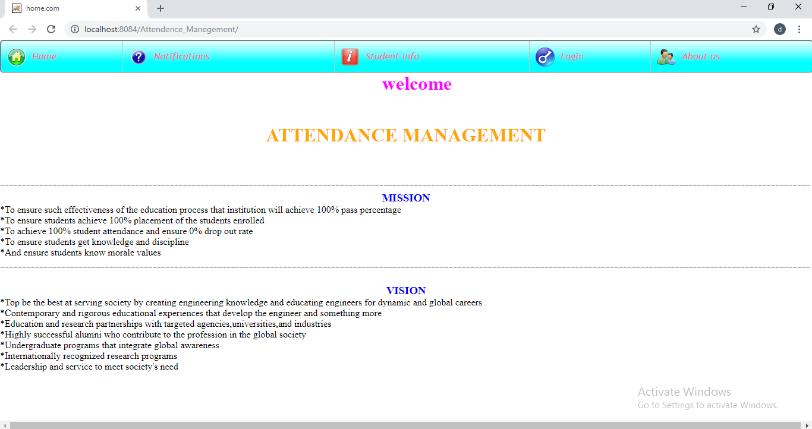 MAIN HOMEPAGE:

* It is a main homepage of our website
* Admin, staff, student all have different logins.
* This website has notifications. It will be updated daily by admin or principal.
* About us shows our college staff and branches details.

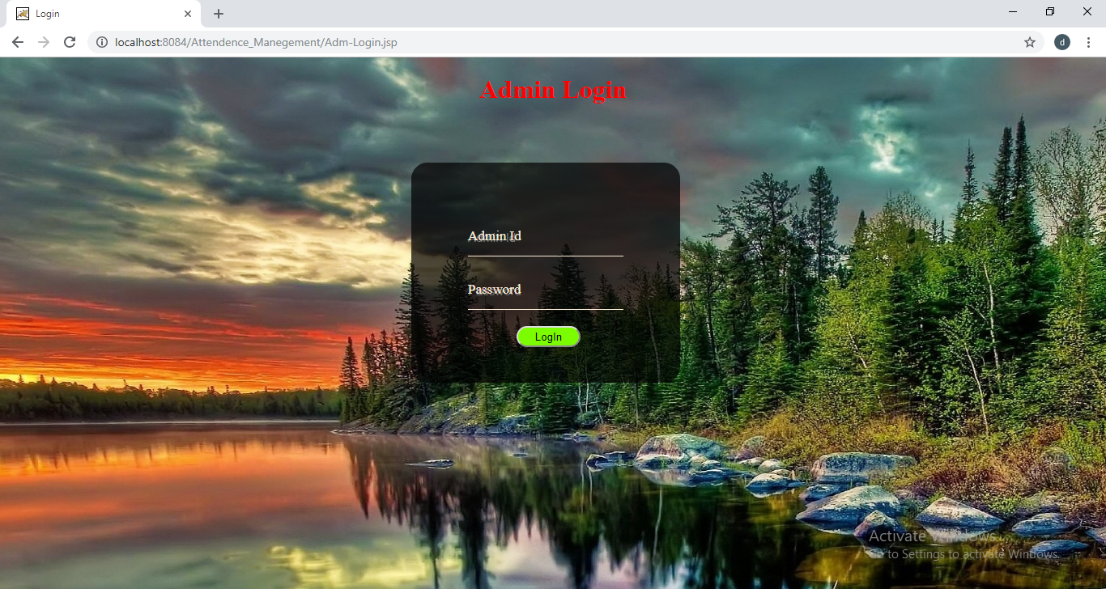 ADMIN LOGIN PAGE :

* It is admin login page.
* The user id and password will be given in the program only
* If the username and password given in login page during login matches it will redirect to admin homepage, if not It redirects to error page.

Admin homepage:

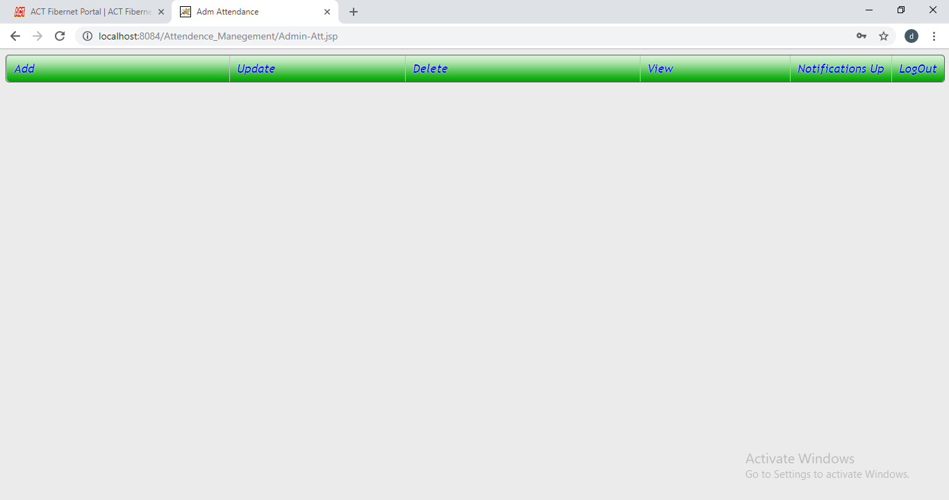

* It is admin homepage.
* when admin login’s it redirects here.
* From here admin will add, update, delete students, and staff. He can also assign staff as class teachers for every branch.
* He can view the whole staff and students details from here. He will also update notifications like holidays, exam dates, attendance alert etc.

Student ADD page:

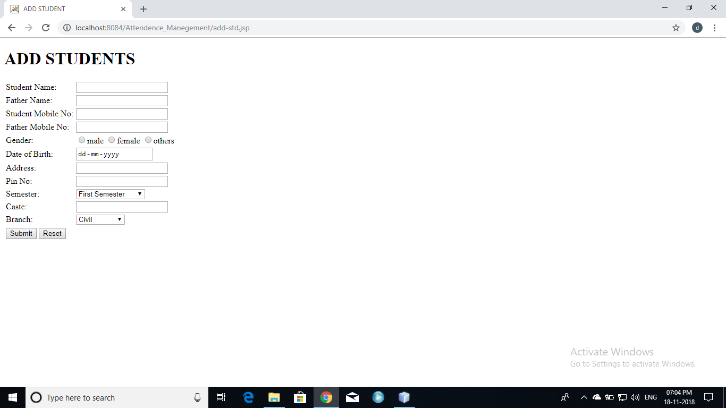

* This page student add page.
* All students will added by admin from here.
* The registered student details will be stored in database in separate table.
* In this pin no or roll no will be primary key.
* By the help of primary key students will login.
* If the same pin no cannot added to other student.

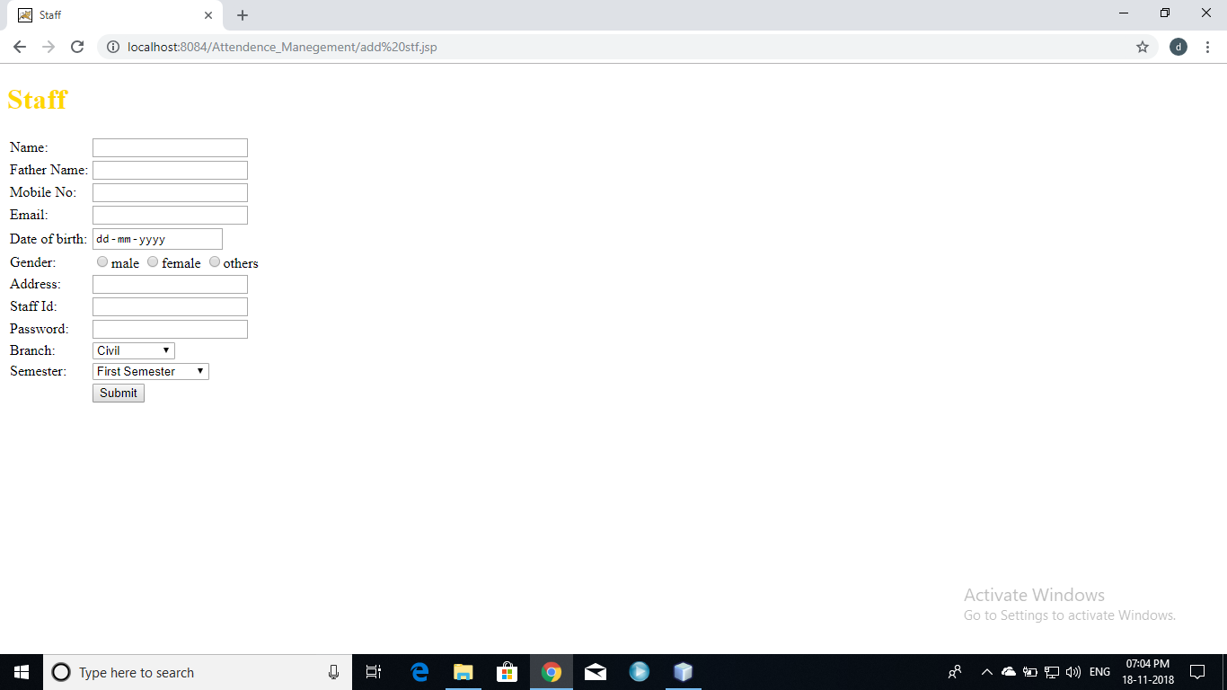 Staff ADD page:

* This staff add page.
* From here admin will add the staff.
* From here the staff will be assigned as class teacher by admin.
* For the primary key will be staff id.
* The staff login password will be given by admin .
* After first time login the staff can change there password as per their wish.

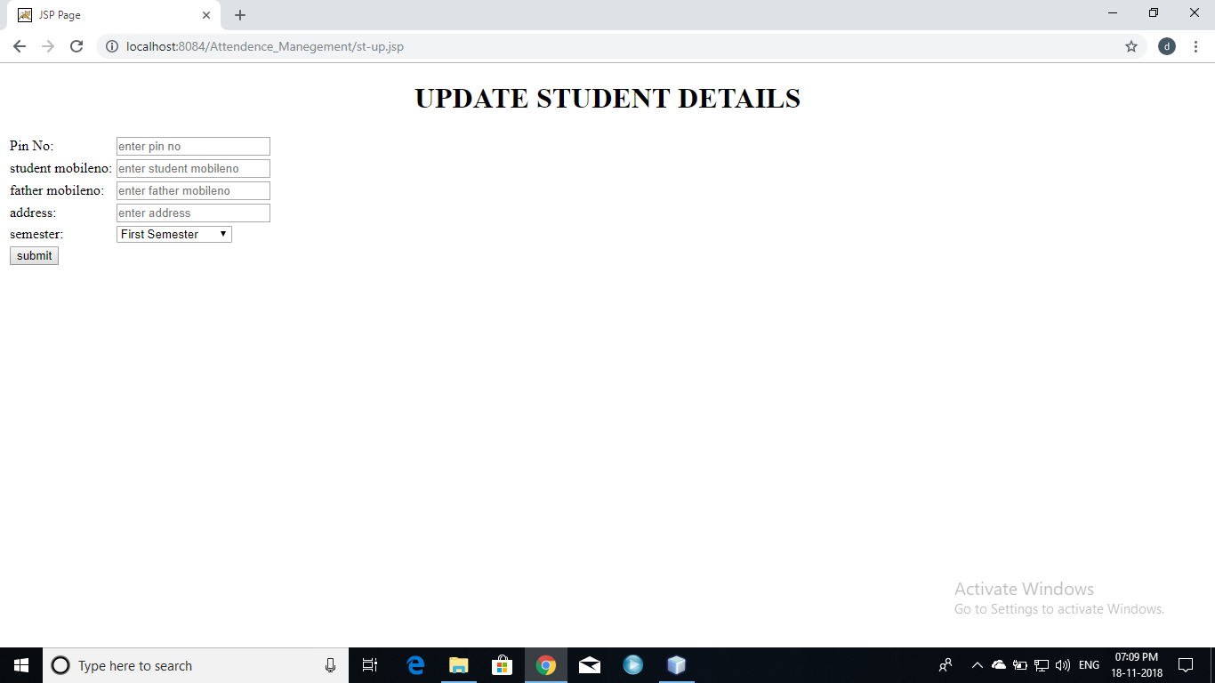Student update page:

* it is student update page.
* In students details if any error present , this page will be used.
* If we update the details here the data stored in database will be replaced with the updated details.

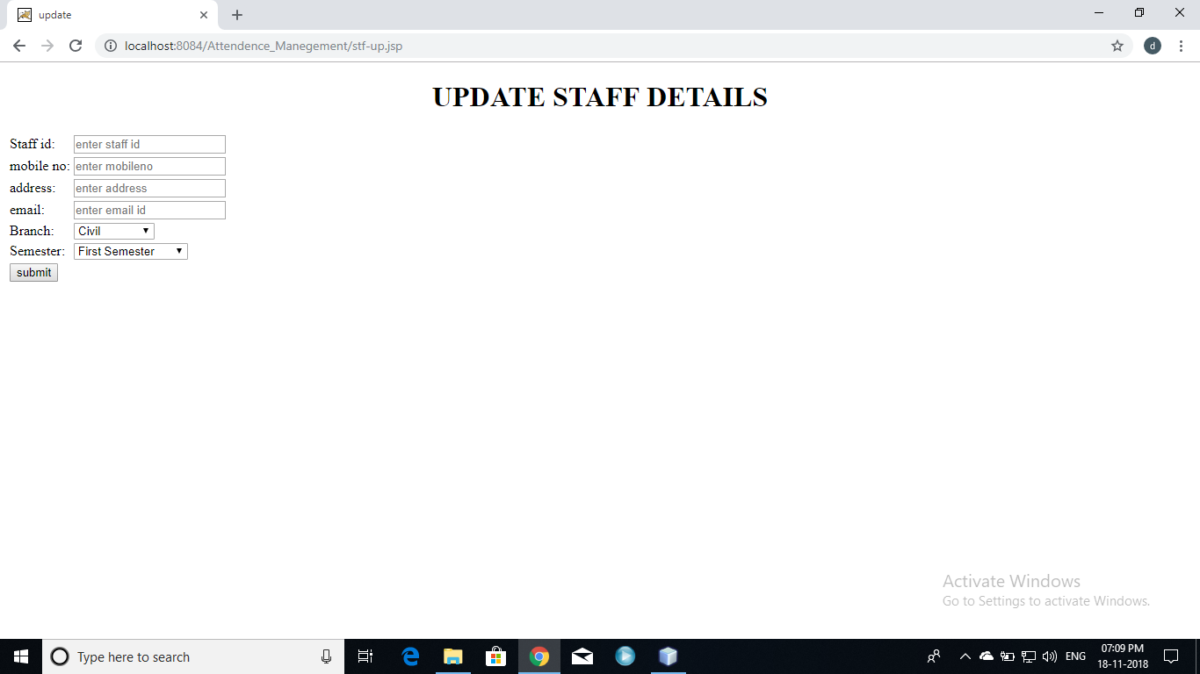 Staff update page:

* it is staff update page.
* In staff details if any error present , this page will be used.
* The class teacher also can change and updated.
* If we update the details here the data stored in database will be replaced with the updated details.

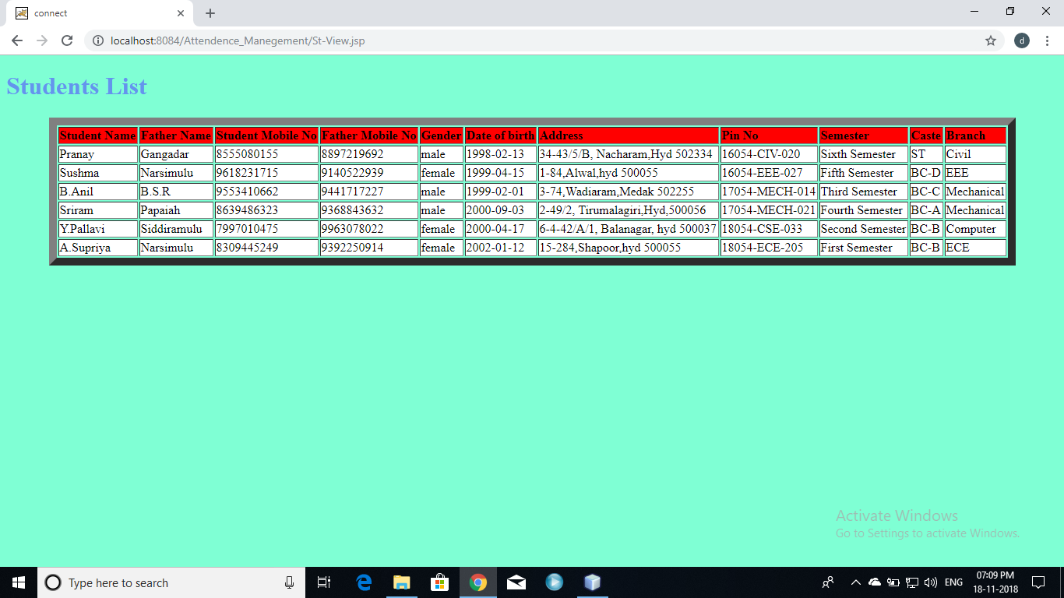Students view page:

* The added students will be viewed with the help of this page.
* The whole students and their details can viewed.

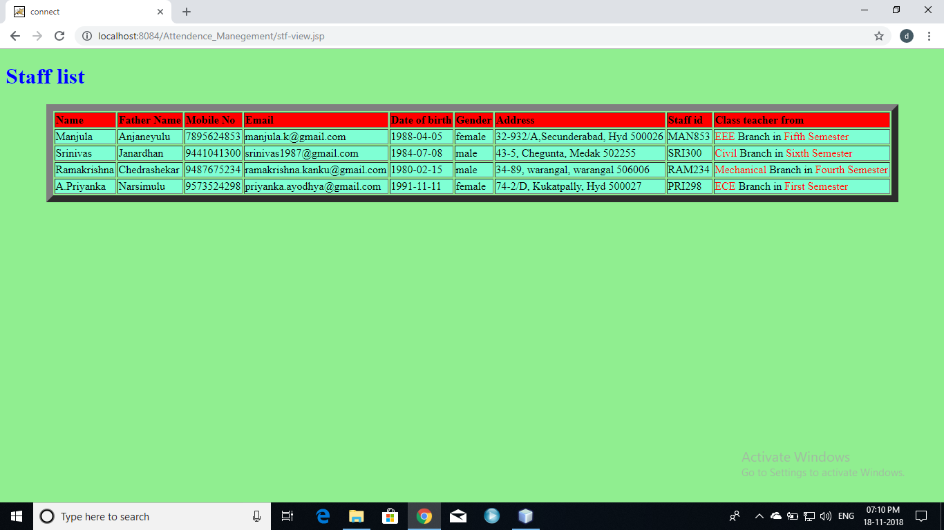Staff view page:

* The added staff will be viewed with the help of this page.
* The whole staff and their details can viewed.
* Admin can see the class teachers he assigned.

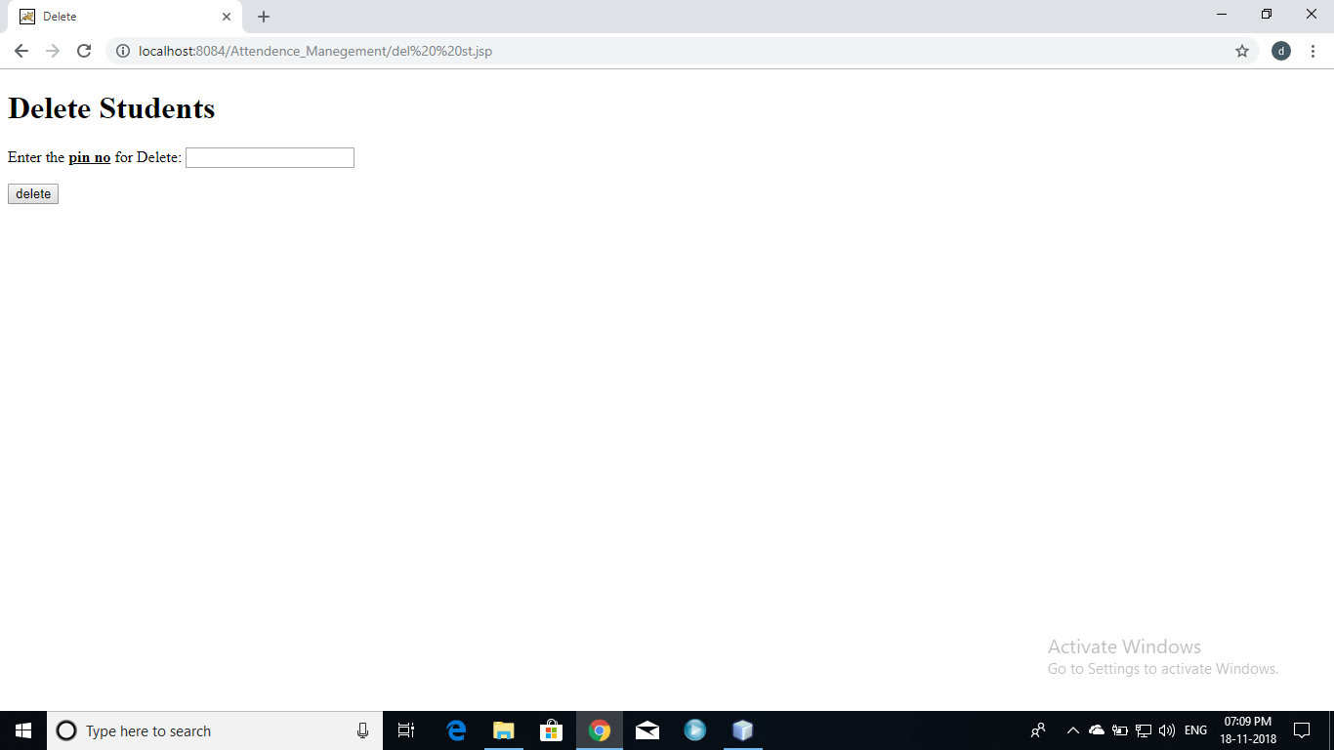Student delete page:

* This page student delete page.
* Students who completed their college and received their certificates will be deleted.

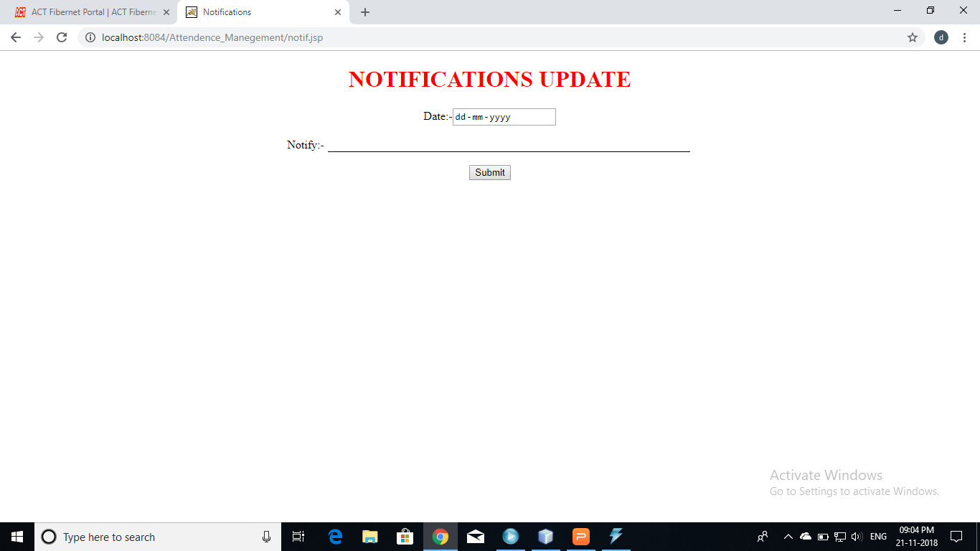 Notification update:

* It notification update page
* From here the notifications will be updated by admin.
* Notifications like holidays, exam time table, attendance etc.., will be updated here.

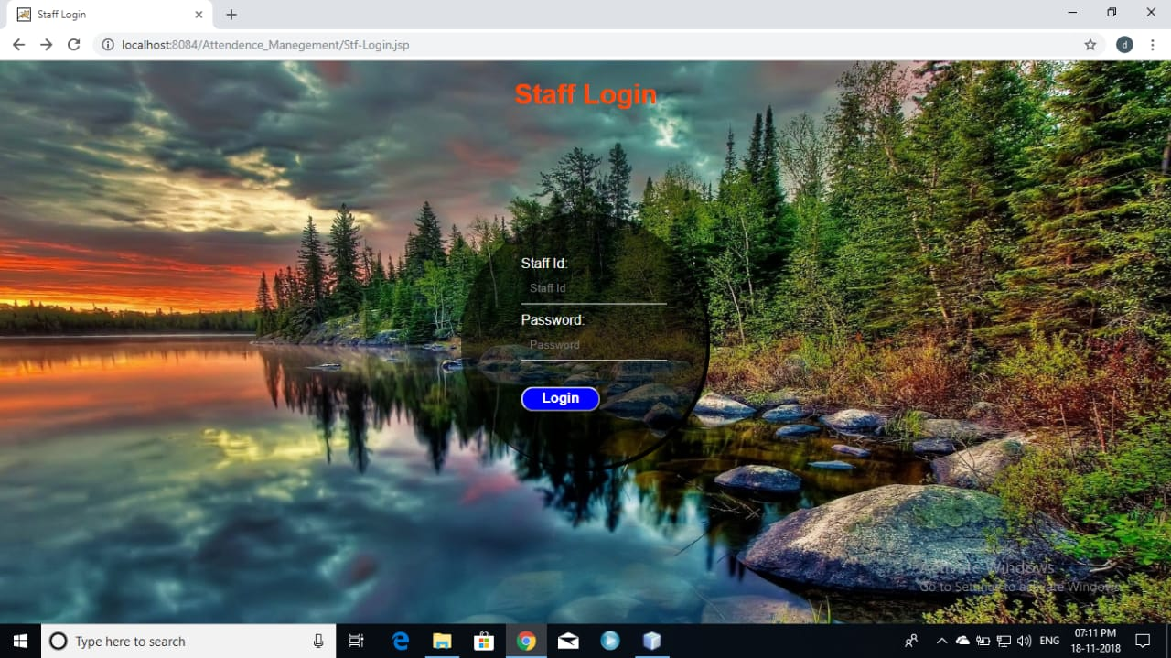 Staff login page:

* This is staff login page.
* The staff entered username and password will compared to registered details which are saved in database.
* If they matches the will be allowed to his account if not he will be denied or shows error

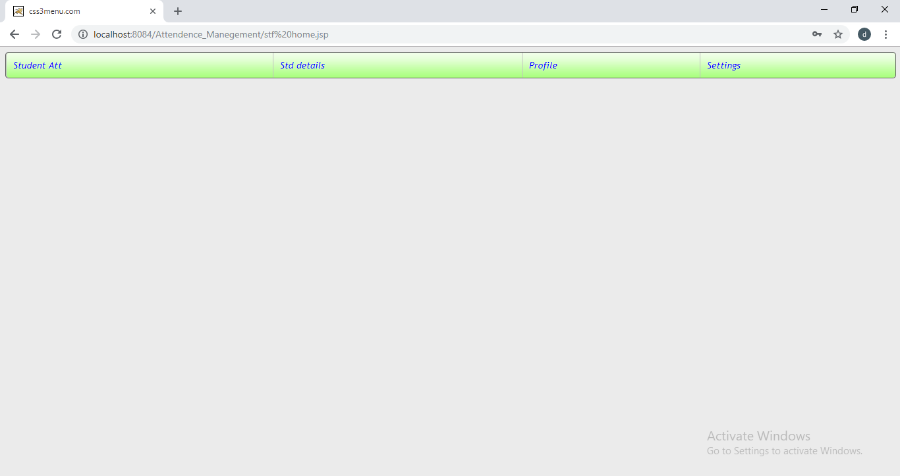 Staff home:

* this is staff homepage.
* In this staff can view their profile.
* they can change their password here.
* They can view their class student details. And also update or add their attendance.

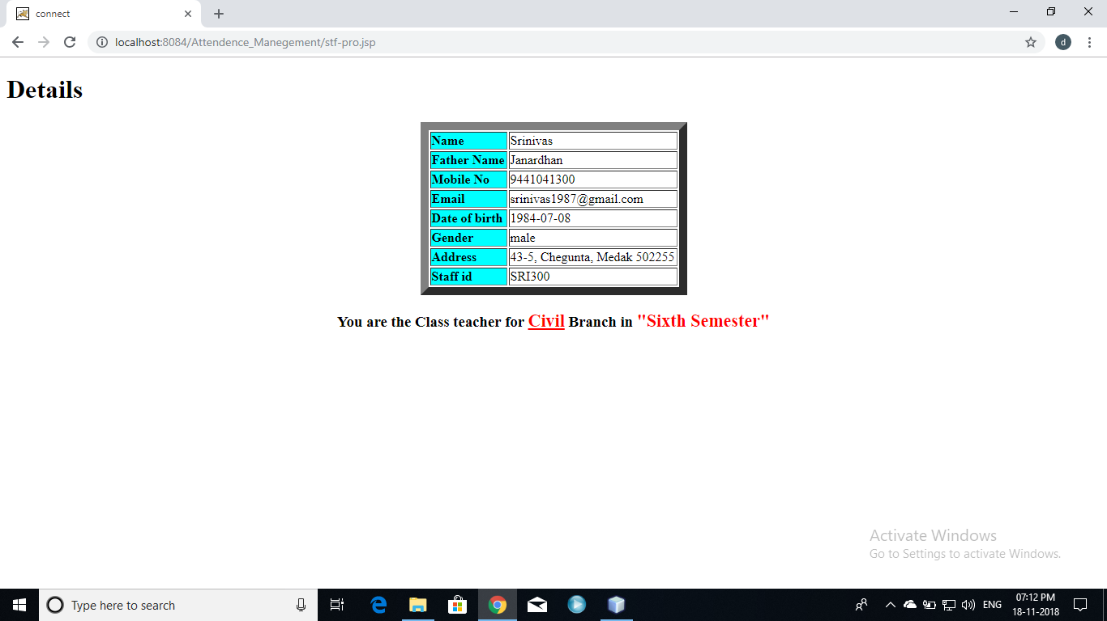 Staff profile page:

* This is staff profile page.
* They can see their details, and they can for which class they are class teachers.

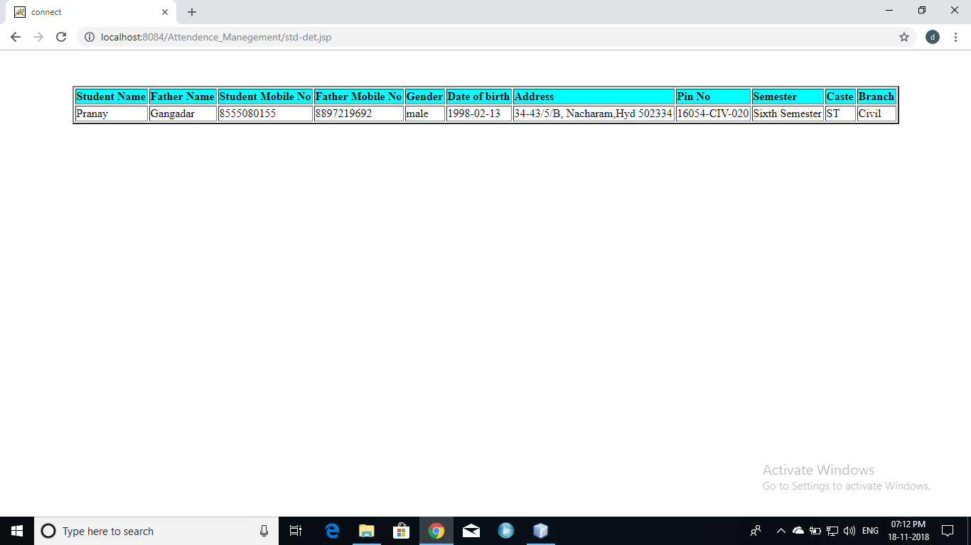

* 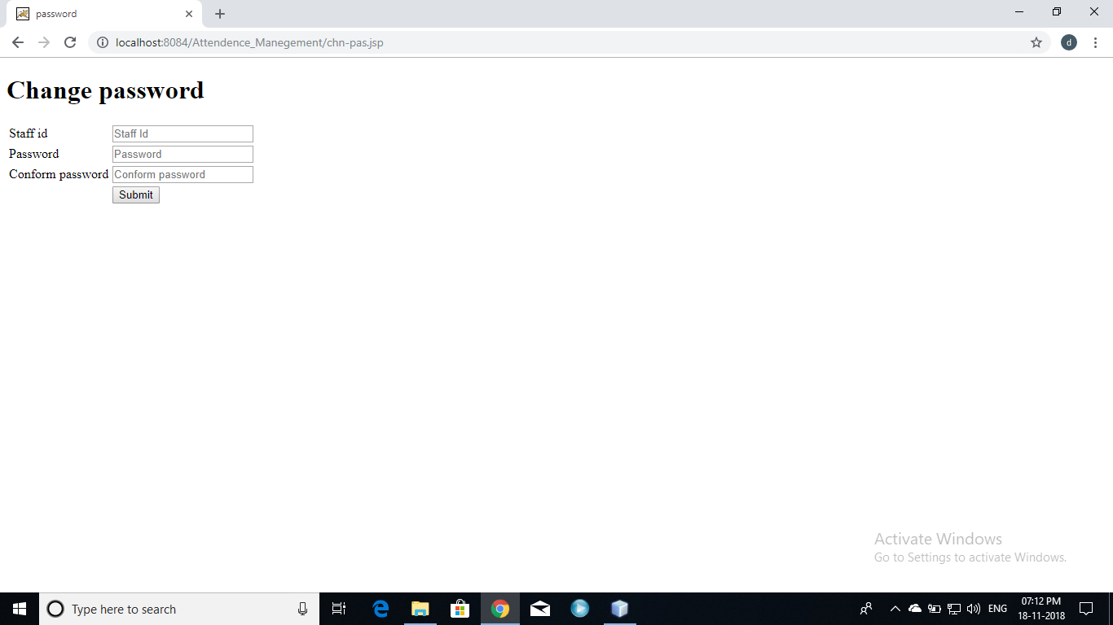they can see their student details under their if they were class teachers of a branch.
* Here the staff can change their password
* The changed password replace the old password in database.

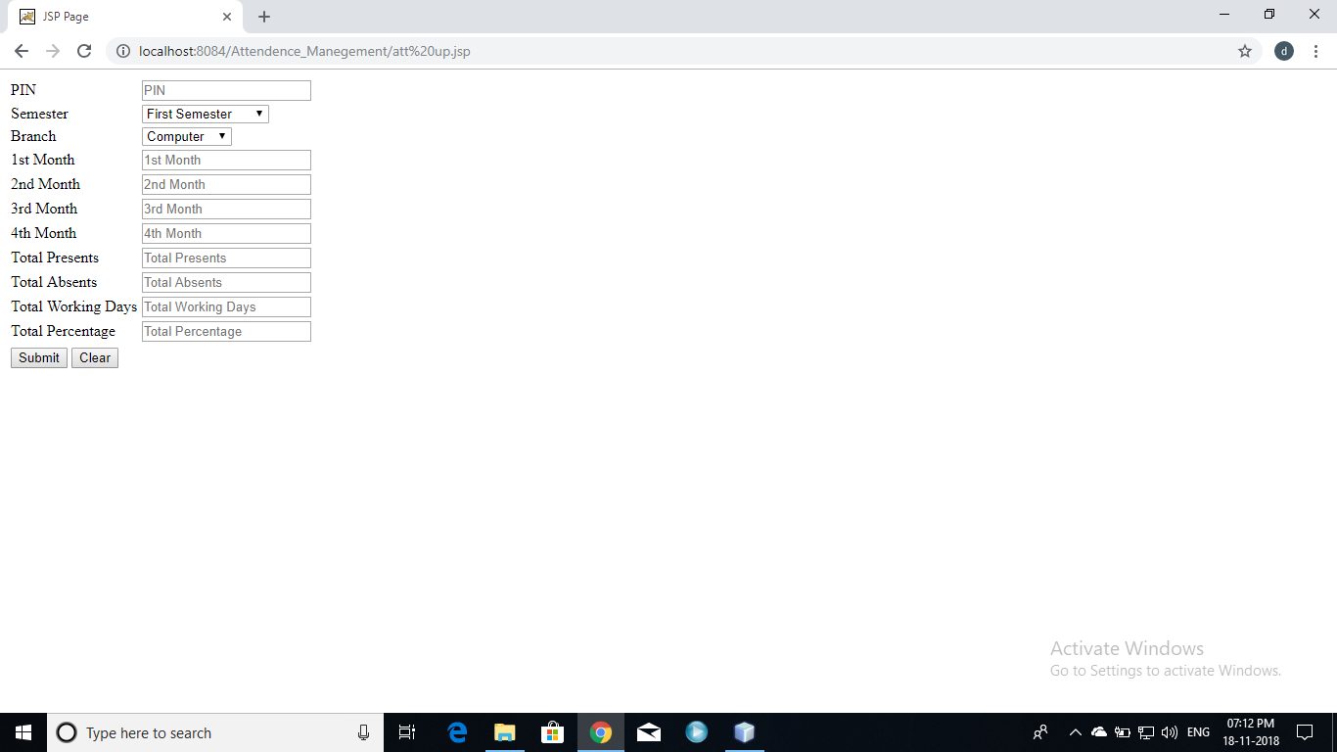 Update student attendance:

* This is update student attendance page.
* The staff will add student attendance according to the records.
* The pinno and semester of student entered by staff should match with student details in database.

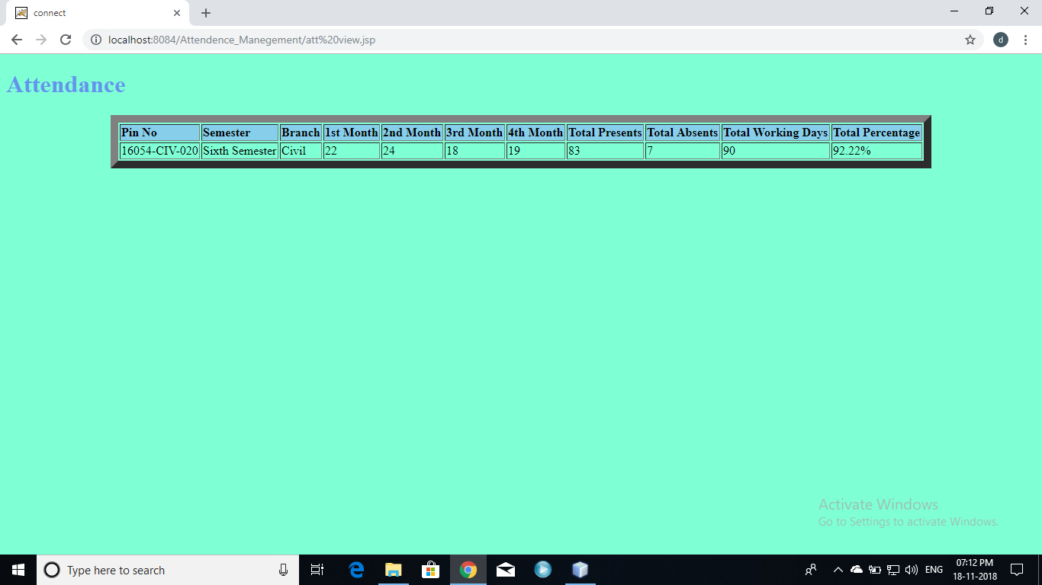view student attendance:

* Here they can see the attendance of students under them.

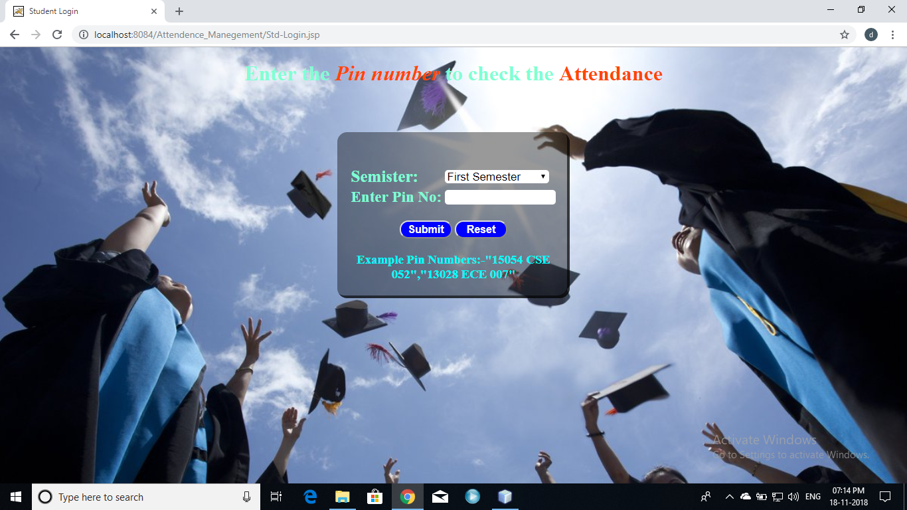 Student login:

* This is student login page.
* The student entered semester and pinno should match with the details present in database.
* Then it redirects to attendance page, if not access will be denied or shows error.

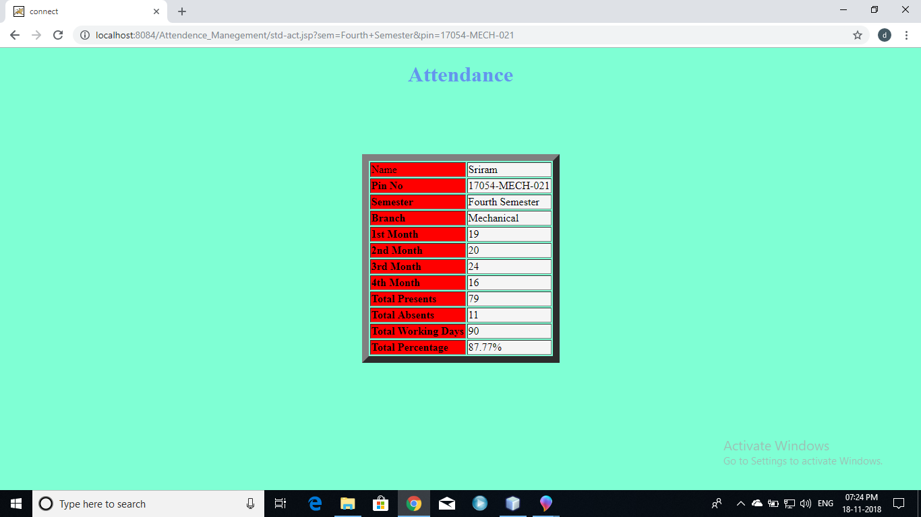 ATTENDANCE:

* This student attendance view page.
* The student will see their attendance here.
* It shows the student attendance monthly.
* Here the student can see their attendance percentage, total presents, absents, working days.

Notifications:

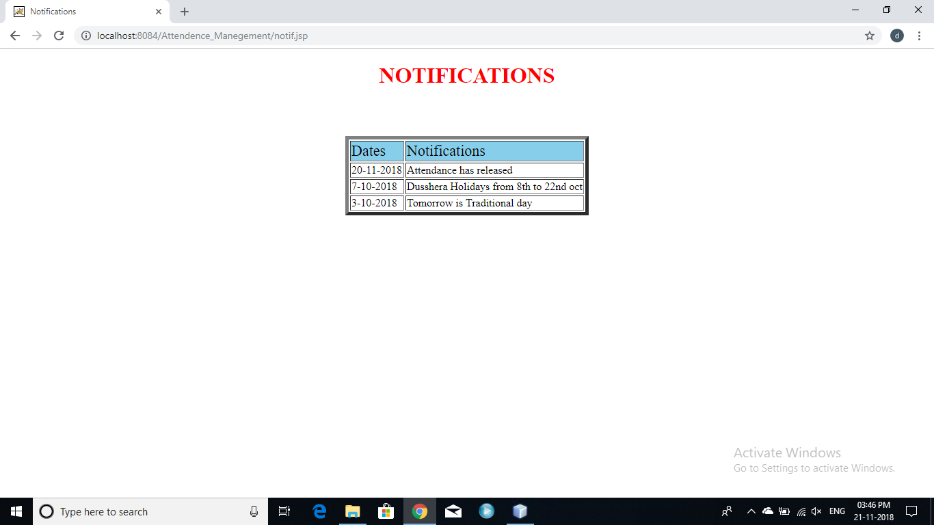

* Here all can see all notifications which were updated by admin.
* Admin will update the notifications daily if any notifications there.

Conclusion:

It helps students and teachers mostly. This avoids the inter-mixing of attendance and details of a student.

It doesn’t required any maintenance of records and books. It can directly maintain from website and database